**National University of Science and Technology, NUST**

Department of Mechanical Engineering

CS-114 - Fundamental of

Programming

Lab Manual # 03

**Course Instructor:** Dr Jawad Khan Lab

**Instructor:** Muhammad Affan

**Student Name:** Muhammad Muzammil Riaz

**CMS ID:** 467817

**Date: 16/10/2023**

1. Write a C++ program to print the total number of populations in Punjab, Sindh, KPK, and Balochistan using a switch case.

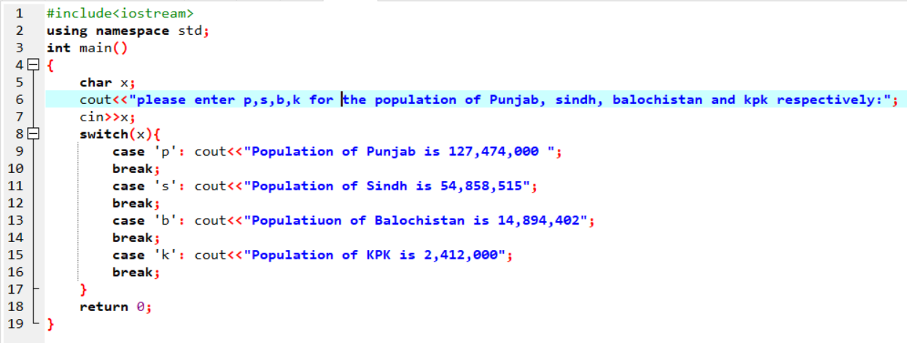

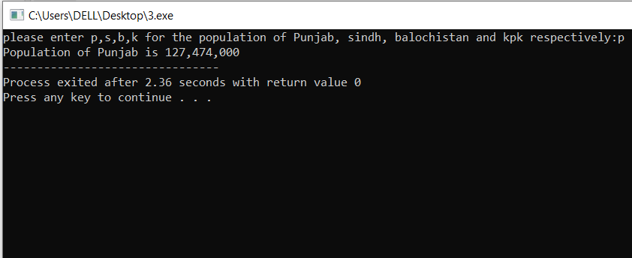

1. Write a C++ program to check whether an alphabet is a vowel or consonant using a switch case.

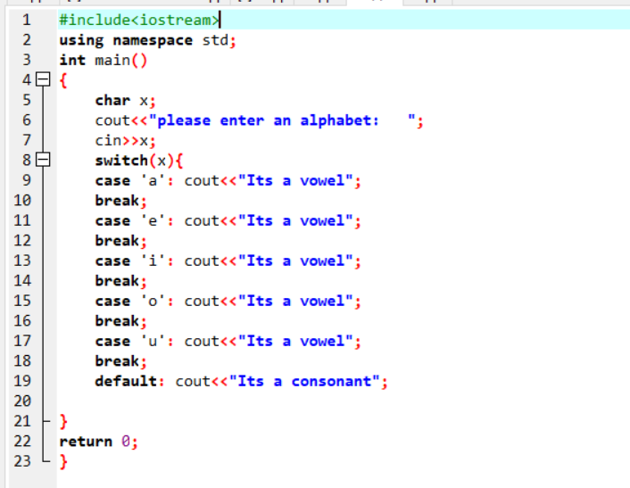

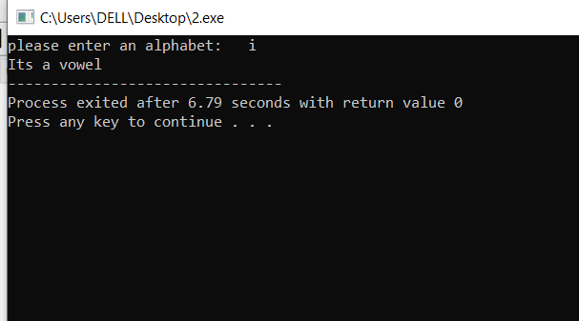

1. Write a C++ program to check whether a number is positive, negative, or zero using a switch case.

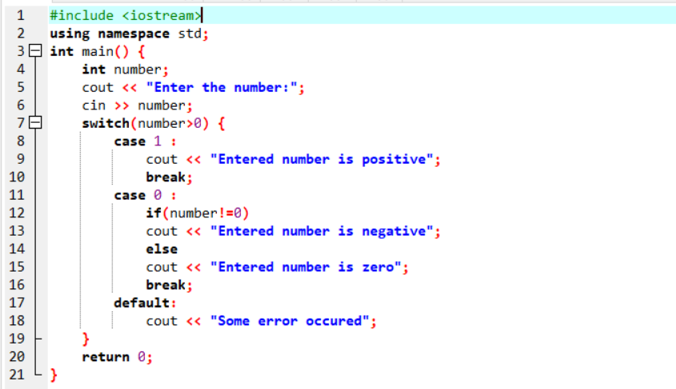

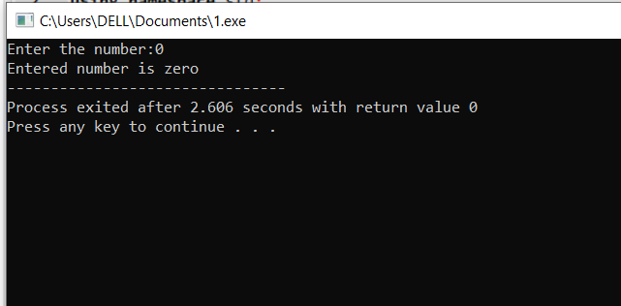

1. Write a C++ to find out whether a person is an adult, teenager, or child using nested if-else.

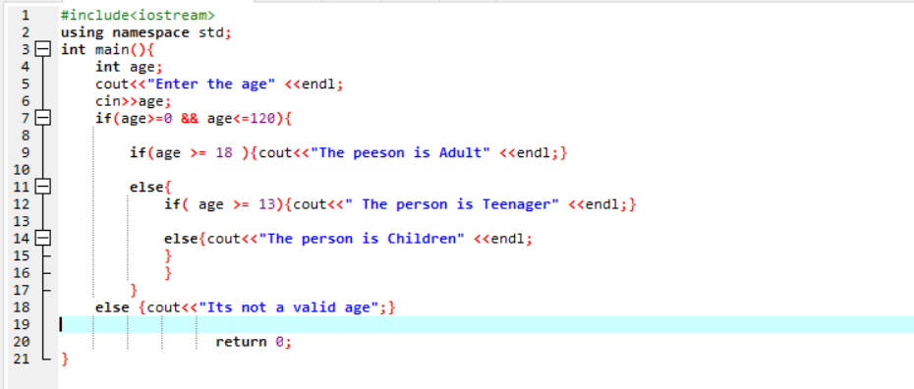

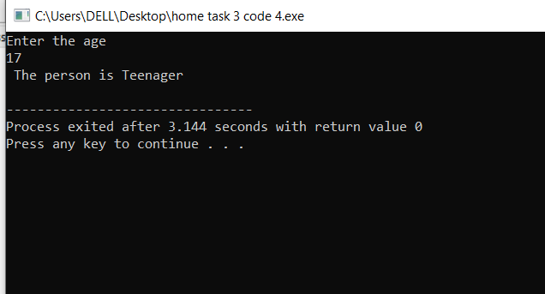

1. Write a C++ program that takes three number from the user and find the greatest number out of the three numbers using nested if-else statements.

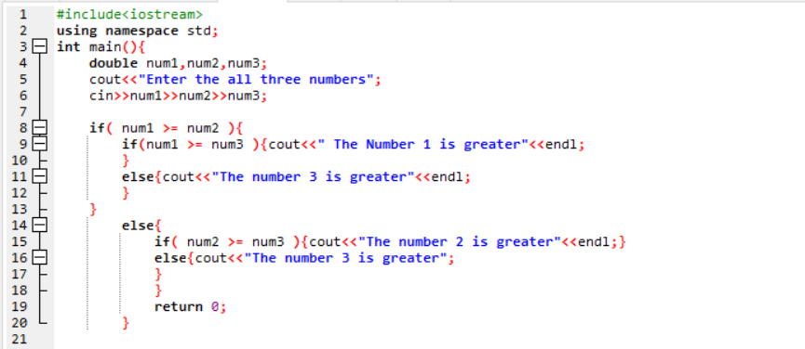

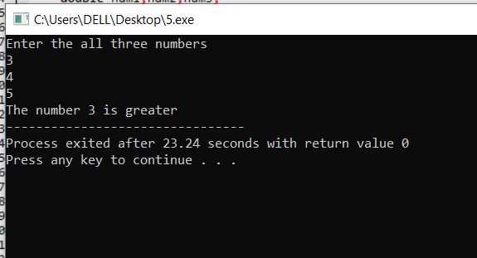

6. Write a C++ program to check whether the alphabet entered by the user is Vowel or Consonant using nested if-else.

